SoftKeyboardTextBox Design
Contents
1 Markup and Code Sample 1
2 Static Class Structure 1
3 Template Contract 2
4 Organizing the Key Map Data 3
5 SoftKey 5
6 SoftKeyboard 6
7 Navigation and Focus 7
8 Localization 10
9 Customization 10
10 API List 11

Markup and Code Sample
Markup:
1. Simplest, it just work:
<SoftKeyboardTextBox />

2. Change key’s template
<SoftKeyboardTextBox SoftKeyTemplate=”…”/>

C#:
1. Simplest, it just work:
SoftKeyboardTextBox textbox = new SoftKeyboardTextBox();

2. Change key’s template
SoftKeyboardTextBox textbox = new SoftKeyboardTextBox();
textbox.SoftKeyTemplate = …
…

Static Class Structure
Fig. 1 Static class structure:
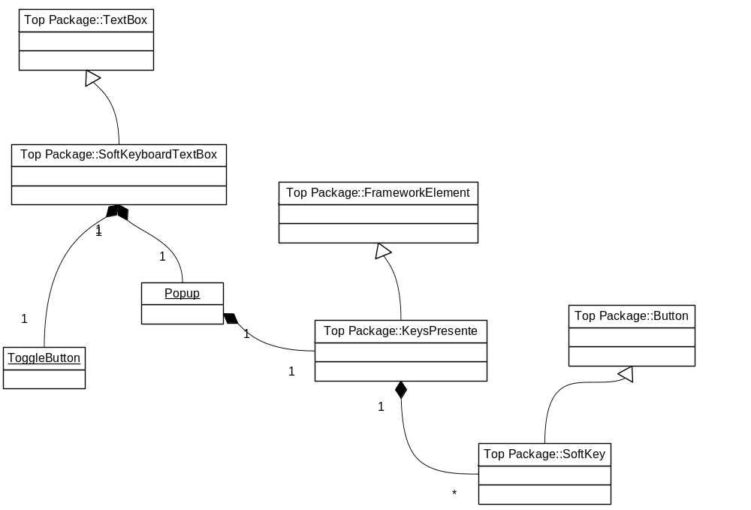

Template Contract
SoftKeyboardTextBox requires below 4 parts in the control template:

- PART_ExpandCollapseButton: this is a ToggbleButton which control the open and close of the soft kb;
- PART_ContentHost: this is required by the TextBox to locate the Text control;
- PART_Popup: this is the popup, inside which you put the soft kb;
- PART_SoftKeyboard: this is the soft kb;

Below has the skeleton:

<Style … TargetType="{x:Type l:SoftKeyboardTextBox}">
<Setter Property="Template">
<Setter.Value>
<ControlTemplate TargetType="{x:Type l:SoftKeyboardTextBox}">
<Grid>
<DockPanel>
<ToggleButton x:Name="PART_ExpandCollapseButton"
DockPanel.Dock="Right" Content="a"
IsChecked="{Binding Path=IsSoftKeyboardOpened,... TemplatedParent}"/>
<Border>
<ScrollViewer x:Name="PART_ContentHost" />
</Border>
</DockPanel>
<Popup Name="PART_Popup"
IsOpen="{Binding Path=IsSoftKeyboardOpened,... TemplatedParent}">
<Border MinWidth="{TemplateBinding ActualWidth}">
<l:SoftKeyboard x:Name="PART_SoftKeyboard"
SoftKeyContainerStyle="{TemplateBinding SoftKeyContainerStyle}"
…/>
</Border>
</Popup>
</Grid>
</ControlTemplate>
</Setter.Value>
</Setter>
</Style>

Organizing the Key Map Data
The default soft keyboard has 2 key maps and each map has 54 keys:
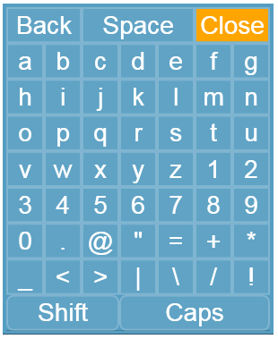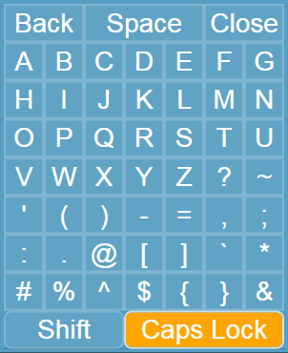
Lower case keyboard | Upper case keyboard

Structure of Each Soft Key Data
Information required for each key are:
- the string to display
- the char and/or the action the key connected with
- the size of the key (1 unit, like most character keys, or 2, 3 …)
- the location of the key

NameKeyPair struct is to address #1 and #2. In most cases, display content is the string format of the char. But some cases, e.g. the Space, it need a different presentation.

ControlKey enum: All these keys falls into 2 major categories: character keys (e.g ‘A’) and controls keys (e.g. ‘Back’, ‘Close’). But unfortunately, not all control keys can find an appropriate key from the System.Windows.Input.Key enum to represent. So we have the ControlKey enum:
public enum ControlKey { None, Back, Space, Close, Shift, Caps }

Character keys use the None value.

Grid is sufficient for layout all the scenarios we identified. So just leverage grid’s property:
Column
Row
ColumnSpan
RowSpan

Data structure: when maps changed, NameKeyPair may or may not change, by all the rest information of a key should remain the same. So we end up with a data structure below:

This is the ‘Close’ key:
<l:SoftKeyData ControlKey="Close" Column="5" ColumnSpan="2">
<l:SoftKeyData.NameKeyPairs>
<l:NameKeyPair DisplayName="Close" />
</l:SoftKeyData.NameKeyPairs>
</l:SoftKeyData>

This is the ‘a’ key:
<l:SoftKeyData Row="1"> // Column=”0” skipped
<l:SoftKeyData.NameKeyPairs>
<l:NameKeyPair Key="a" /> // DisplayName skipped
<l:NameKeyPair Key="A" />
</l:SoftKeyData.NameKeyPairs>
</l:SoftKeyData>

Below has the public APIs:

public class SoftKeyData
{
// Properties
public int Column { get; set; }
public int ColumnSpan { get; set; }
public ControlKey ControlKey { get; set; }
public List<NameKeyPair> NameKeyPairs { get; }
public int Row { get; set; }
public int RowSpan { get; set; }
}

public struct NameKeyPair
{
public string DisplayName { get; set; }
public char Key { get; set; }
}

Putting Keys Together
The keys are organized in a generic list and stored in the theme as a resource. XAML doesn’t support generic in V1, so I derived one from List<SoftKeyData> as a workaround:

public class SoftKeyDataList : List<SoftKeyData> { }

Now I am able to write this in markup:

<l:SoftKeyDataList x:Key="...">
<l:SoftKeyData ControlKey="Back" ColumnSpan="2">
</l:SoftKeyData>
...
</l:SoftKeyDataList>

Why do this? A couple of benefits:
- make localization a lot more easier.
- Make experience of editing the keyboard data (in source code level) similar to layout elements in a Grid

SoftKey
Soft key have these features:
- is a Button, perform an action after each click
- is a ToggleButton for some of the keys, e.g. Shift, CapsLock
- Templating each key
- Styling each key
- Update content when key map changes

One single type for all soft keys: All soft keys fall into 2 categories: Button and ToggleButton. But having two types of SoftKey controls add complexity elsewhere:
- Will have 2 sets of SoftKeyStyle prperyties on SoftKeyboard and SoftKeyboardTextBox (b/c their target type are different)
- complex for data loading
- …

Also because .Net support only single inheritance, I make one SoftKey control derive from Button to handle the two types of keys.

public class SoftKey : Button, IRemoteInputElement, IKeyboardMessageFilter
{
// Events
public event RoutedEventHandler Checked;
public event RoutedEventHandler Unchecked;

// Methods
protected virtual void OnChecked(RoutedEventArgs e);
protected virtual void OnUnchecked(RoutedEventArgs e);

internal void LoadData(SoftKeyData data);
internal void UpdateNameKeyPair(int index);

// Properties
public char Char { get; }
public ControlKey ControlKey { get; }
public bool IsChecked { get; set; }
public bool IsToggleKey { get; }
…
}

SoftKeyboard
SoftKeyboard is responsible for
- Loading data and certain properties and create a panel with the keys
- Provide keyboard navigation functionality (will be dressed in next section)
- Response to click event, make change to the targeting TextBox (e.g. insert a character), make change to the keyboard (e.g. change keymap) or perform an action (e.g. close the keyboard)
- Update key map when they need to be changed
- Maintaining certain state information, e.g. last focused key
- …

Change key map
Shift key and Caps key together decide which key map should be used,. Below has a table for the toggle state combination and corresponding key map

Table 1 Control key state and corresponding key map
Caps | Shift | Keyborad
False | False | En Lower case
False | True | En Upper case
True | False | En Upper case
True | True | En Lower case

When key map change is requested, all soft keys except togglable ones will be call to update their NameKeyPair. Togglable key is responsible to update their NameKeyPair when their toggle state changed.

Delay SoftKey loading
If SoftKeyboard is within a popup and never show up, there is no need to populate the keys. Only create the panel and keys with data when the first time the popup is asked to show.

Navigation and Focus

Show Two Focus
When SoftKeyboard is opened, we need to show two focus, one is on the SoftKeyboard to indicate the current focused key. We need other one on the TextBox, to indicate the place for the next input. So we set the attach property FocusManager.IsFocusScope as true to the popup. So that the popup will be treated as a different focus scope and TextBox will retain the focus.

Note that there is only one Keyboard focus at a time, so all input message will go to the focused soft key.

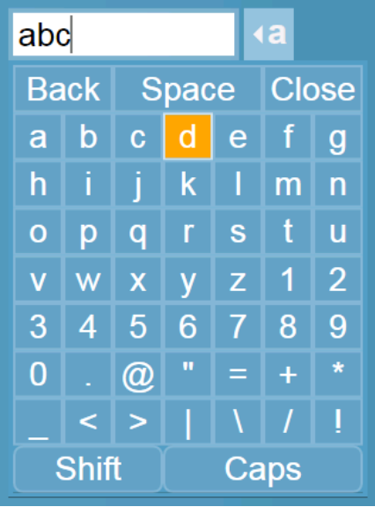

Move Focus between Controls
SoftKeyboardTextBox handle PreviewKeydown. If focus is on TextBox and caret is at the boundary of the text, move focus to
  - ExpandCollapse button, or
  - other control in the direction nearby
Similar if focus is on the ExpandCollapse button.

See below table and picture has more details

Key input | New focus
Left | Button ‘4’
Right | ExpandCollapse button
Right twice | Button ‘6’
Up | Button ‘2’
Down | Button ‘8’
Table: Directional key input and new focus:

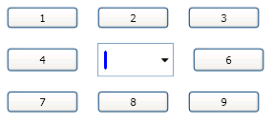 | 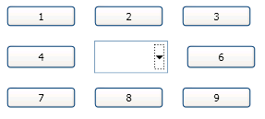
(a) focus on edit site | (b) focus on expandcollapse button
Fig. SKBTextBox has focus

Directional Navigation inside SoftKeyboard
- Initial focus
Snapshot of SKBTextBox with KB opened. The very first open of the SoftKeyboard, focus will be on the ‘Close’ key.

- DirectionalNavigation=”Cycle”
Cycle navigation can help to minimize the strokes needed to move focus to the next key user wanted.
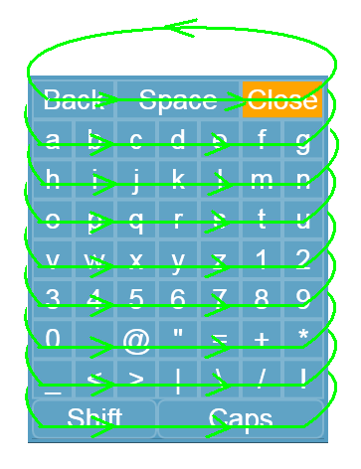
Cycle horizontally
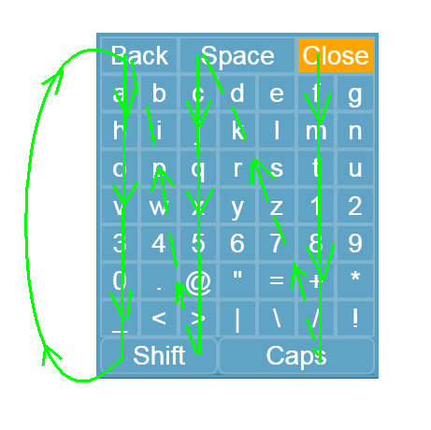
Cycle vertically

Localization
WPF has good support for localize resource in the xaml/baml. Please refer to the SDK document follow:
Conceptual Topics -> Globalization and Localization -> Globalization and Localization How-to Topics -> How to: Localize an Application

Or my step by step document and sample code:
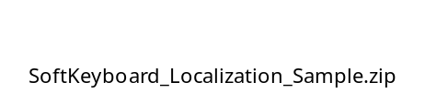

Below has a screenshot of the result:

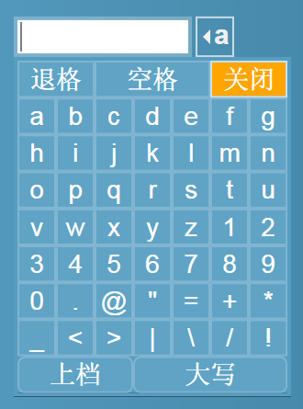
Screenshot of SoftKeyboard localized to zh-CN (Chinese) culture

Customization
There are 3 categories user might want to change the soft-keyboard:
- the display content of some / all of the soft-keys
- the input content of the soft-key (esp. for internal user, might change characters to their local text)
- the key as well as of the layout of the keymap (e.g. for Calculator app, you need only 0-9 and . + - * / = etc.)

For #1 and #2, user can directly edit the SoftKeyDataList (in Generic.xaml). For #3, user need to rewrite the whole list. Below has an example of a number only keyboard:

<l:SoftKeyDataList x:Key="NumMap">

<l:SoftKeyData Column="0" Row="0">
<l:SoftKeyData.NameKeyPairs>
<l:NameKeyPair Key="7" />
</l:SoftKeyData.NameKeyPairs>
</l:SoftKeyData>
<l:SoftKeyData Column="1" Row="0">
<l:SoftKeyData.NameKeyPairs>
<l:NameKeyPair Key="8" />
</l:SoftKeyData.NameKeyPairs>
</l:SoftKeyData>

...

<l:SoftKeyData ControlKey="Back" Column="1" Row="3" ColumnSpan="2">
<l:SoftKeyData.NameKeyPairs>
<l:NameKeyPair DisplayName="Back" />
</l:SoftKeyData.NameKeyPairs>
</l:SoftKeyData>
</l:SoftKeyDataList>

Below has the screenshot
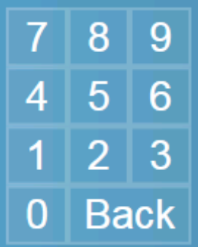
A number only custom keyboard

API List
public class SoftKeyboardTextBox : TextBox
{
// Events
public event RoutedEventHandler SoftKeyboardClosed;
public event RoutedEventHandler SoftKeyboardOpened;

// Methods
public SoftKeyboardTextBox();
protected virtual void OnSoftKeyboardClosed(RoutedEventArgs e);
protected virtual void OnSoftKeyboardOpened(RoutedEventArgs e);

// Properties
public bool IsSoftKeyboardOpened { get; set; }
public Style SoftKeyContainerStyle { get; set; }
public DataTemplate SoftKeyTemplate { get; set; }
public DataTemplateSelector SoftKeyTemplateSelector { get; set; }

// Fields
public static readonly DependencyProperty IsSoftKeyboardOpenedProperty;
public static readonly RoutedEvent SoftKeyboardClosedEvent;
public static readonly RoutedEvent SoftKeyboardOpenedEvent;
public static readonly DependencyProperty SoftKeyContainerStyleProperty;
public static readonly DependencyProperty SoftKeyTemplateProperty;
public static readonly DependencyProperty SoftKeyTemplateSelectorProperty;
}
public class SoftKeyboard : FrameworkElement
{
// Methods
public SoftKeyboard();

// Properties
protected UIElement Child { get; set; }
public Style SoftKeyContainerStyle { get; set; }
public DataTemplate SoftKeyTemplate { get; set; }
public DataTemplateSelector SoftKeyTemplateSelector { get; set; }
public TextBox TargetTextBox { get; set; }

// Fields
public static readonly DependencyProperty SoftKeyContainerStyleProperty;
public static readonly DependencyProperty SoftKeyTemplateProperty;
public static readonly DependencyProperty SoftKeyTemplateSelectorProperty;
public static readonly DependencyProperty TargetTextBoxProperty;
}

public class SoftKey : Button
{
// Events
public event RoutedEventHandler Checked;
public event RoutedEventHandler Unchecked;

// Methods
public SoftKey();
protected virtual void OnChecked(RoutedEventArgs e);
protected virtual void OnUnchecked(RoutedEventArgs e);

// Properties
public char Char { get; }
public ControlKey ControlKey { get; }
public bool IsChecked { get; set; }
public bool IsToggleKey { get; }

// Fields
public static readonly DependencyProperty CharProperty;
public static readonly RoutedEvent CheckedEvent;
public static readonly DependencyProperty ControlKeyProperty;
public static readonly DependencyProperty IsCheckedProperty;
public static readonly DependencyProperty IsToggleKeyProperty;
public static readonly RoutedEvent UncheckedEvent;
}

public class SoftKeyData
{
// Methods
public SoftKeyData();

// Properties
public int Column { get; set; }
public int ColumnSpan { get; set; }
public ControlKey ControlKey { get; set; }
public List<NameKeyPair> NameKeyPairs { get; }
public int Row { get; set; }
public int RowSpan { get; set; }
}

public struct NameKeyPair
{
public string DisplayName { get; set; }
public char Key { get; set; }
}

Notes:
- The DisplayName, Char, and ControlKey properties will be assigned to, respectively, the Content, Char and ControlKey properties

public enum ControlKey
{
None,
Back,
Space,
Close,
Shift,
Caps
}

Notes:
- If and only if a SoftKey is loaded with a SoftKeyData which has ControlKey property as Shift, Caps or Intl, the IsToggleKey property on the SoftKey will be set to true.

